What to do to run?
Your project is here - D:\Capgemini\Practice\Smart Foundry\SmartFoundry Project\src\js
Css folder is where your css is and src\index.html is where your html is.

Structure

App.js
In hello.js, you will have below. So, you when you hit http://localhost:3000/ or http://127.0.0.1:3000/, you will see the index.htm.
app.get('/', function (req, res) {
res.sendFile(path.resolve('../index.html'))
})

Inserting in MySQL
app.post('/finalSubmit', function (req, res) {
console.log('Submitting...!!!!')
var sql = "insert into users values('"+req.body.companyName+"','"+req.body.region+"')"
connection.query(sql, function (err) {
if (err) throw err
console.log("data saved!")
// connection.end();
// console.log("Connection ended!")
// res.render('index', { title: 'Data Saved!!!', message: 'Data save success!'})
// res.render('', {req: req.body});
// res.redirect('/');//redirect to the page from where request came
res.status(204).send();
})
})
and then it has lots of divs and input fields. Notice all input or button fields will have name
These are the things we are going to pass in the mysql.

Index.pug
Your index.pug will be like this:
html
head
title= title
body
h1= message
This is what you will use when rending, but I have cmmented for now because if you see in above to above code, I have used status 204 which will not render a new page. If you want to render a new page, then use below code:
res.render('index', { title: 'Data Saved!!!', message: 'Data save success!'})
# How to run
**Focus only on 'src' part. **
The project structure for now is a mess, still you can run the following command in TWO TERMINALS/CMD:
```
npm run watch:sass-2
Go to src/js and run ===> nodemon app.js
```
Now go to http://localhost:3000 and submit the form

Program 1:
Save file like hello.js
const http = require('http');

const hostname = '127.0.0.1';
const port = 3000;

const server = http.createServer((req, res) => {
res.statusCode = 200;
res.setHeader('Content-Type', 'text/plain');
res.end('Hello World\n');
});

server.listen(port, hostname, () => {
console.log(`Server running at http://${hostname}:${port}/`);
});
Run the file: $ node hello.js
You will see:
Server running at http://127.0.0.1:3000/
Open it and you will see “Hello World”
Program 2:
const url = require('url');

const webAddress = 'http://www.example.com/dataman/?id=1234&age=23'
const urlData = url.parse(webAddress)
console.log(urlData)
Output:
Url {
protocol: 'http:',
slashes: true,
auth: null,
host: 'www.example.com',
port: null,
hostname: 'www.example.com',
hash: null,
search: '?id=1234&age=23',
query: 'id=1234&age=23',
pathname: '/dataman/',
path: '/dataman/?id=1234&age=23',
href: 'http://www.example.com/dataman/?id=1234&age=23'
}

If you want to get hostname, then use
console.log(urlData.hostname)

Create your own module
Create a new js file called mymodule.js
module.exports = function(num) {
console.log('Square is: ' + num * num)
}
In your main js file
const square = require('./mymodule')
console.log(square(5)) // Square is: 25

Express JS
Install using npm install express
Example program:
const express = require('express')
const app = express()
const port = 3000

app.get('/', (req, res) => {
res.send('Hello World!')
})

app.listen(port, () => {
console.log(`Example app listening at http://localhost:${port}`)
})
Run this using “node hello.js”
You will see a message “app listening at http://localhost:3000”
Go there and you will see Hello World message
Live update is not there. You need to rerun the program ie restart the server.
Install nodemon globally. Meaning, open cmd using windows key and then enter the below command

Live server:
$ npm install nodemon
Then
$ nodemon hello.js

Template Engine
It’s a structure where you can create variables and in runtime update those variables & render it to browser.
$ npm install pug –save
Create a folder called “views” where your main js file is & put below content
html
head
title= title
body
h1= message

In your hello.js. We are changing the title of the page and message. See above, you have given title and h1. It is an HTML, see above. That is what you are modifying below:
const express = require('express')
const app = express()
const port = 3000

app.set('view engine', 'pug')

app.get('/', function (req, res) {
res.render('index', { title: 'Hey Express', message: 'Hello there!' })
})

app.listen(port, () => {
console.log(`Example app listening at http://localhost:${port}`)
})

Run “node hello.js” and you will see in the browser it is updated.
If I want to give my own:
html
head
title= title
body
h1= message
h2= myOwn
and in hello.js you can use like below
const express = require('express')
const app = express()
const port = 3000

app.set('view engine', 'pug')

app.get('/', function (req, res) {
res.render('index', { title: 'Hey Express', message: 'Hello there!', myOwn: 'Sajjad here' })
})

app.listen(port, () => {
console.log(`Example app listening at http://localhost:${port}`)
})
Run node hello.js and you will see h1 and h2 in browser

Hello there!

Sajjad here

Render HTML form to browser with NodeJS
First create index.html folder
<!DOCTYPE html>
<html lang="en">
<head>
<meta charset="UTF-8">
<meta name="viewport" content="width=device-width, initial-scale=1.0">
<title>Document</title>
<link rel="stylesheet" href="css/bootstrap.min.css">
</head>
<body>
<div class="container">
<form action="/submit" method="post" class="form-horizontal">
<fieldset>
<!-- Form Name -->
<legend></legend>

<!-- Text Input -->
<div class="form-group">
<label for="name" class="col-md-4 control-label">Name</label>
<div class="col-md-4">
<input type="text" id="name" name="name" placeholder="Enter Name" class="form-control input-md">
</div>
</div>

<!-- Text Input -->
<div class="form-group">
<label for="email" class="col-md-4 control-label">Email</label>
<div class="col-md-4">
<input type="text" id="email" name="email" placeholder="Enter Email" class="form-control input-md">
</div>
</div>

<!-- Text Input -->
<div class="form-group">
<label for="mobile" class="col-md-4 control-label">Mobile</label>
<div class="col-md-4">
<input type="text" id="mobile" name="mobile" placeholder="Enter Mobile Number" class="form-control input-md">
</div>
</div>

<!-- Button -->
<div class="form-group">
<label for="Submit" class="col-md-4 control-label"></label>
<div class="col-md-4">
<button type="text" id="submit" name="submit" class="btn btn-primary">Save</button>
</div>
</div>

</fieldset>
</form>
</div>
</body>
</html>

Go to hello.js and now you are sending that index.html. You need to mention the root dirname as well.
const express = require('express')
const app = express()
const port = 3000

app.set('view engine', 'pug')

app.get('/', function (req, res) {
res.sendFile('index.html', {root: __dirname})
})

// app.get('/', function (req, res) {
// res.render('index', { title: 'Hey Express', message: 'Hello there!', myOwn: 'Sajjad here' })
// })

app.listen(port, () => {
console.log(`Example app listening at http://localhost:${port}`)
})

You might notice the following line in index.html
<link rel="stylesheet" href="css/bootstrap.min.css">
And CSS might have not applied. To do that, go to
https://getbootstrap.com/docs/4.1/getting-started/download/ and download
To access CSS file inside nodejs application, then use express.static method. This is to include all static files like image, css or js
Assume that this is your css file path: D:\Capgemini\Practice\Smart Foundry\SmartFoundry Project\src\js\node\css\bootstrap.min.css
And this is your hello.js file path: D:\Capgemini\Practice\Smart Foundry\SmartFoundry Project\src\js\node\hello.js
So, you have to give like below:
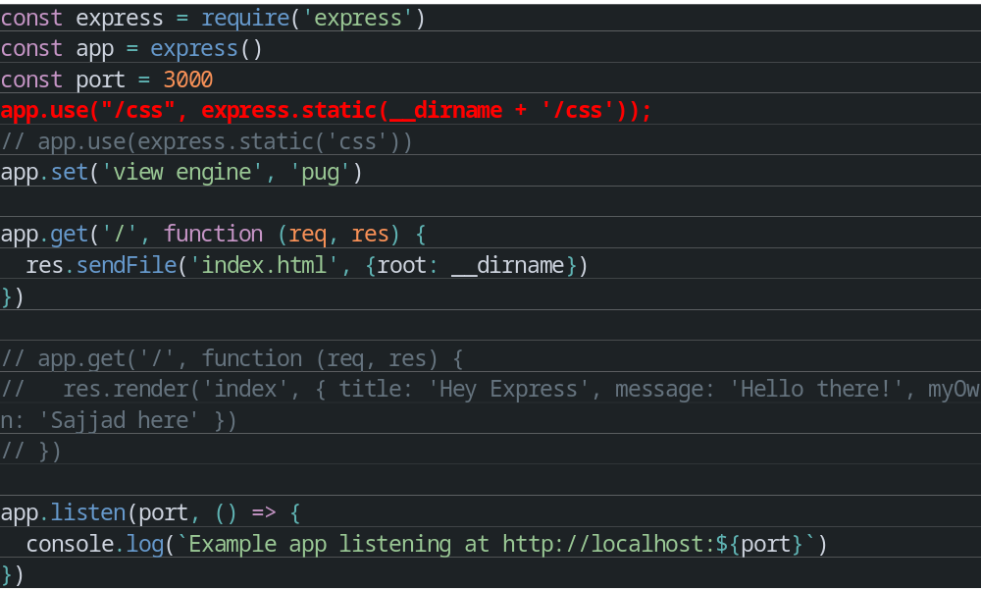
So, now would have got form with css.
Now when you submit the form, we have to read the data from the form, you need to do like below:
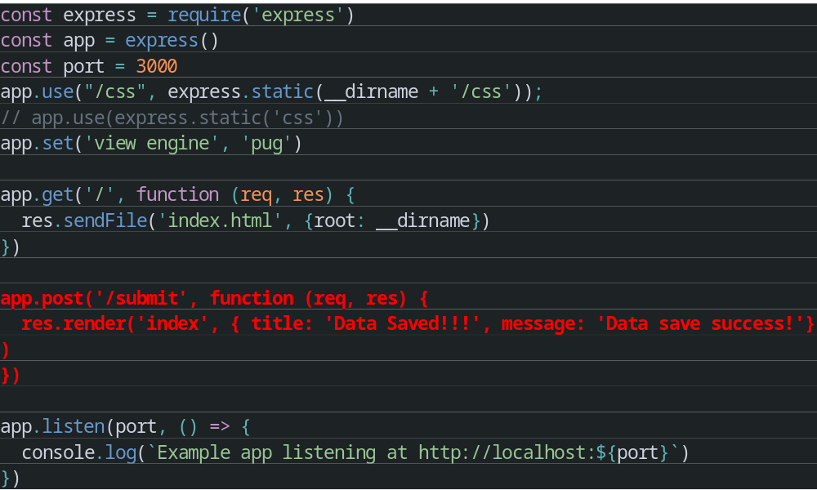
What is /submit?
In index.html, we have given like below:
<form action="/submit" method="post" class="form-horizontal">

Index.pug
html
head
title= title
body
h1= message

If you have to get the data and parse, then include below library:
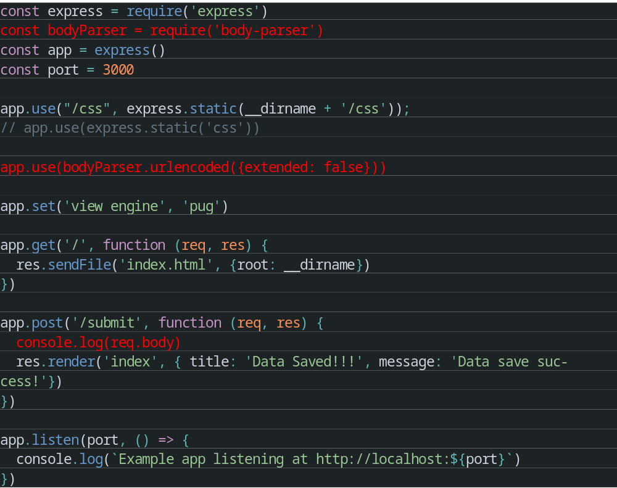
Now go and submit the form, you will see following in terminal:
{
name: 'test',
email: 'test@asd.com',
mobile: '123',
submit: ''
}

Installing MySQL and XAAMP
To install MySQL watch this video - https://www.youtube.com/watch?v=7S_tz1z_5bA from 10:00 to 15:00
Download and install XAAMP - https://www.apachefriends.org/
Open XAAMP Click ‘start’ on Apache and MySQL.
You will get an error like:
08:08:13 [Apache] Error: Apache shutdown unexpectedly.
08:08:13 [Apache] This may be due to a blocked port, missing dependencies,

Watch this video - https://www.youtube.com/watch?v=knqw368RNXk
After fixing what he has told on the video, open http://localhost:8080/phpmyadmin/
Getting MySQL said: Cannot connect invalid settings error? Watch this - https://www.youtube.com/watch?v=8fK_DYvosA8
Once phpMyAdmin is opened, click ‘Databases’ create database give somename. Your database is created.
Click on the database. You will see “No tables found in database.”
Enter any table name like “users”, click Create/Go
Watch this video - https://www.youtube.com/watch?v=lldeWkkG9xA
You might stuck at the “connected” message not displaying in terminal. It might be because you might have put password because you had set the password in mysql. Just give empty password like below:
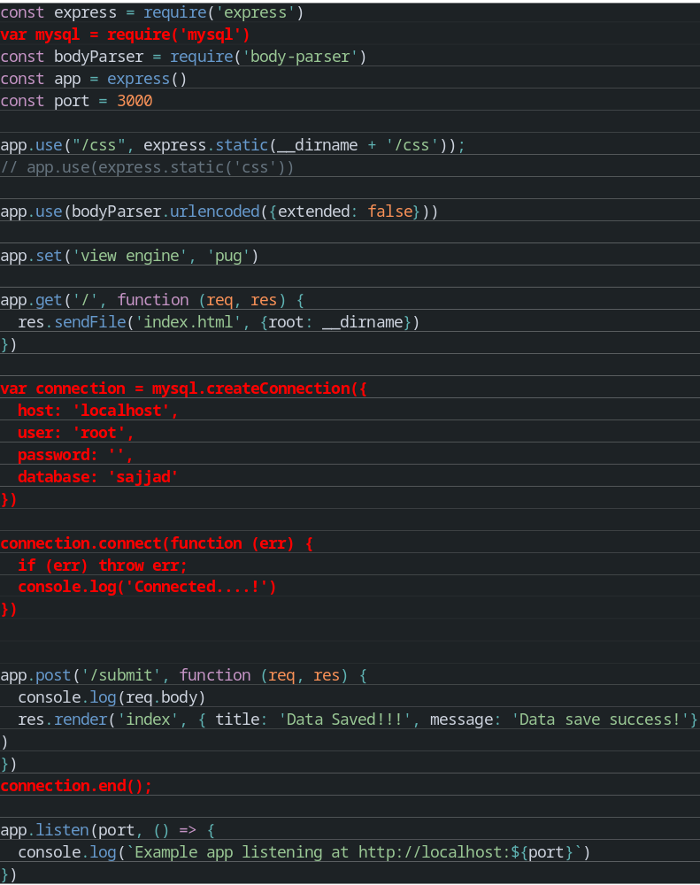

Now we need to insert our data
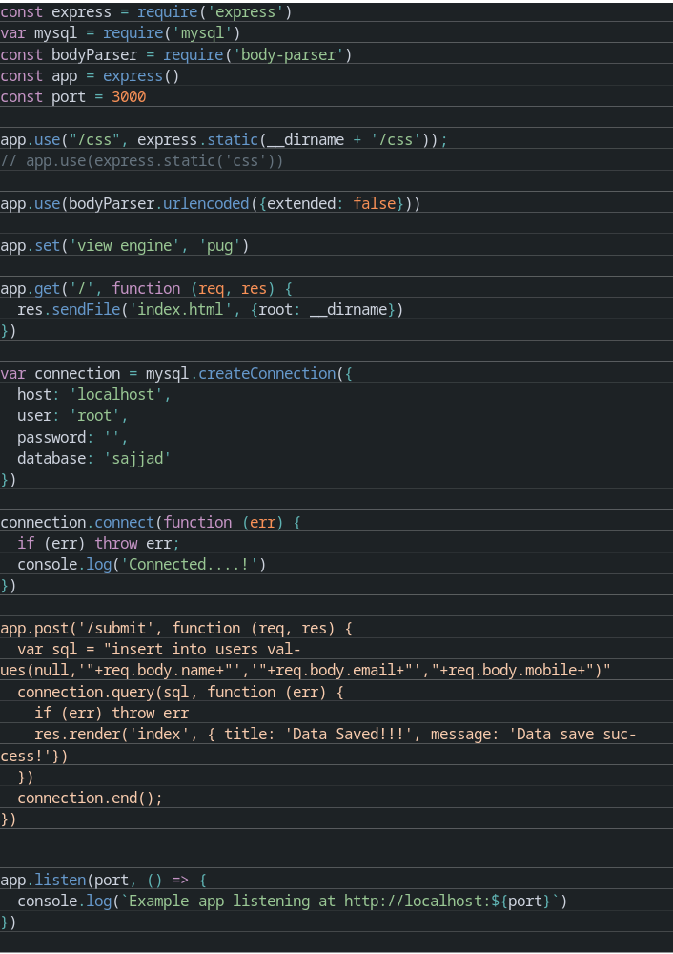
Go to our forms page (http://127.0.0.1:3000/)
Submit the form
You will see the same data in database.

MySQL Errors

#1049 Unknown database
Check this one - https://www.youtube.com/watch?v=nDDbLpx6RKo

Client does not support authentication protocol requested by server; consider upgrading MySQL client
Solution:
Execute the following query in MYSQL Workbench
ALTER USER 'root'@'localhost' IDENTIFIED WITH mysql_native_password BY 'password'

MYSQL Queries

To add a new column
ALTER TABLE users ADD first_name VARCHAR(20) NOT NULL
Explanation: change the ‘users’ to your table name
‘first_name’ should your column name

Modifying an existing column
ALTER TABLE Person MODIFY P_Id INT(11) NOT NULL;

Update column values
UPDATE users SET email_address = "asda" WHERE email_address IS NULL;

Delete rows
DELETE FROM users ORDER BY email_address LIMIT 10;

Delete Column
ALTER TABLE users DROP COLUMN email_address;

